Store

**sw**

Testing code:

addi x1, 0, 90

sw x1, 0(x)

Note that the **base address** that we store our data in is at 64

So as shown in the screenshot, the data is stored at this location in the memory

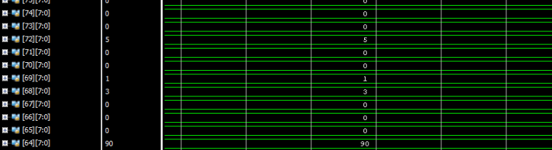

**sh**

Testing code:

addi x1, 0, 1000

sh x1, 0(x)

The number 1000 is written in binary as: 0000001111101000 and it written in the two bytes at locations 64 and 65.

Byte 65 contains the value 00000011 while byte 64 contains the value 11101000 if we concatenated them together, we will get 0000001111101000 which is number 1000.

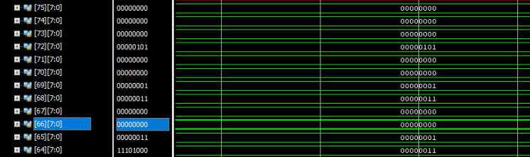

**sb**

Testing code:

addi x1, 0, 1000

sb x1, 0(x)

Note that I store the first byte of the number 1000 which is 11101000 equivalent to 232 in decimal which is stored in location 64 in memory

